|  |
| --- |
|  |
| 新概念 3 册 |
| Lesson47 |

Lesson 47 Too high a price ?

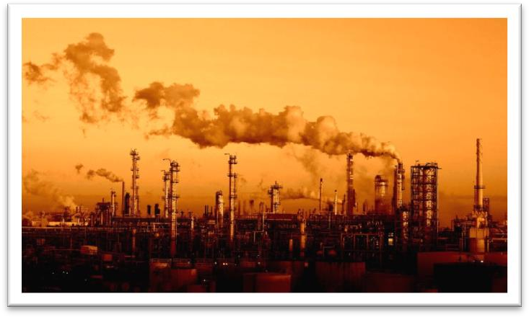

**overpopulated [əʊvə'pɒpjuleɪtɪd] adj. 人口过多的**

overworked overdressed

overestimated overcrowded

overcooked over-industrialized

overpopulated overpopulation

China is faced with the problem of overpopulation. populate

densely / thickly populated regions sparsely / thinly populated regions **overwhelm [əʊvə'welm]**

v. 大水淹没某地

The village was overwhelmed by floods.

be overwhelmed with / by *grief / despair / excitement* ... In June the town is overwhelmed by tourists.

I feel a little bit overwhelmed by work. Her beauty completely overwhelmed him.

Government troops have overwhelmed the rebels. overwhelming

an overwhelming victory the overwhelming majority **insidious [ɪn'sɪdiəs]**

adj. 潜在的，潜伏的，暗中为害的

an insidious disease insidious jealousy “sid / sed” = sit

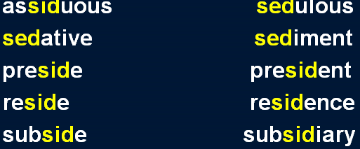

I wanna hold you till I die, till we both break down and cry. I wanna hold you till the fear in me subsides.

profound [prə'faʊnd]

**adj. 深刻的，深远的，极度的**

a profound effect / influence / impact a profound poem

a profound question profound sadness profound irritation **maximum ['mæksɪməm] adj. 最大的**

maximum amount / number maximum temperature maximum voltage

maximize

to maximize profits to maximize windows maximization

the maximization of profits minimum minimum wage minimize

to minimize the civilian casualties minimization

mobile ['məʊbaɪl] ['moʊbl] adj. 可移动的

mobile home mobile library mobile phone

cell / cellular phone

hostile docile

fertile fragile

futile infantile

juvenile missile

agile reptile

snore [snɔ:(r)]

**v. 打呼噜，打鼾**

snore sneeze

sniff gasp

sigh yawn

blow one’s nose clear one’s throat

break wind fart

Pollution is the price we pay for an overpopulated, over industrialized planet. Environmental pollution is becoming increasingly serious.

Environmental pollution is a serious problem / issue. Environmental pollution is a global problem / issue.

Environmental pollution is an issue that crosses the national boundaries. We should pay attention to the issue of environmental pollution.

We should show concern for environmental pollution.

We should attach more importance / significance to the issue of environmental pollution. We should make efforts to tackle the problem of environmental pollution.

be the price sb. pay for ...

造句：沙尘暴 (dust storm) 是我们为过度砍伐 (tree felling) 付出的代价。

Dust storms are the price we pay for excessive tree felling. 造句：这次事故是他为疏忽 (negligence)付出的代价。The accident is the price he pays for his negligence.

be a small price to pay for sth.

造句：损失点钱对于提高地位来说算不了什么。

The loss of money is a small price to pay for the rise in status. be a high price to pay for sth.

造句：为了成功牺牲健康不值得。

The sacrifice of health is a high price to pay for success.

When you come to think about it, there are only four ways you can deal with rubbish: *dump it, burn it, turn it into something you can use again, attempt to produce less of it*.

come to do

Future historians will be in a unique position when they come to record the history of our own times.

there are ... ways / kinds / sorts / types / categories / classes ...

There are three categories of accommodation: economical, standard and deluxe. fall into ... categories

Shakespeare’s plays fall into three categories: tragedies such as Hamlet, comedies such as The Merchant of Venice and histories such as Henry Ⅳ.

be divided into ... classes

Broadly speaking, human beings may be divided into three classes: those who are toiled to death, those who are worried to death, and those who are bored to death.

dispose of rubbish / garbage rubbish / garbage disposal recycle it

We keep trying all four methods, but the sheer volume of rubbish we produce worldwide threatens to overwhelm us.

the sheer volume of sth. the sheer size of sth.

The sheer size of the country makes communications difficult. threaten to do

They threatened to kill him if he didn’t obey.

Mining operations threaten to destroy our environment. promise to do

He promised to call me every week. It promises to be warm today.

当 “part of” 之前没有形容词修饰时，通常不加不定冠词 “a”

Justice is part of the complex machinery of the law. This idyllic pastoral scene is only part of the picture. Memory loss is a *normal* part of the aging process.

The need to produce ever-increasing quantities of cheap food leads to a different kind of pollution.

the ever-changing world

the ever-growing knowledge the ever-developing economy the ever-expanding market the ever-deepening reform the ever-dwindling resources

满足人们不断增长的物质和文化生活需求的需要

the need to satisfy people’s ever-increasing demands for material and cultural life Hundreds of steps lead to the high wall which surrounds the president's palace. This led to yet another angry argument.

pig farming cattle farming chicken farming poultry farming livestock farming

farm

farmed fish farmed shrimp produce cheap meat products assist burglars to burgle

live a ... life sing a song breathe one’s last breath

die a glorious death eat chicken

lamb turkey duck lobster ...

The price we pay for cheap food may be already too high: *Mad Cow Disease (BSE) in cattle,*

*salmonella in chicken and eggs, and wisteria in dairy products*. the price sb. pay for ...

Pollution is the price we pay for an overpopulated, over-industrialized planet. The precious information came at a price.

The precious information came at a heavy price. She is determined to have a child at any price. at the expense of ...

Military strength is often achieved at the expense of a country’s economic health.

The Roosevelt Administration believed that rebuilding the nation’s soil was in the national interest and was not simply a plan to help farmers at the expense of other citizens.

BSE:

bovine spongiform encephalopathy AIDS:

Acquired Immune Deficiency Syndrome cattle people police

dairy dairy products dairy cattle diary keep a diary

angle / angel altitude / latitude aboard / abroad

造句：我们为人口过多付出的代价可能已经太高了：失业现象，各种各样的污染，以及越来越多的 (ever-increasing) 犯罪。

The price we pay for overpopulation may be already too high: unemployment, pollution of all kinds, and the ever-increasing crime.

And if you think you'll abandon meat and become a vegetarian, you have the choice of very expensive organically-grown vegetables or a steady diet of pesticides every time *you think you're eating fresh salads and vegetables, or just having an innocent glass of water*!

have the choice of A or B organically-grown vegetables organically-grown produce environment-friendly environment-friendly products a steady job / income

a steady relationship

a steady boyfriend / girlfriend a steady decline / increase every time (when) ... whenever ...

no matter when ...

innocent adj. harmless, innocuous

造句: 如果你想放弃开车, 那么你可以两者选一: 或者是慢得出奇 (extraordinarily slow) 的公共汽车,或者是过分拥挤 (over-crowded) 的地铁。

If you think you’ll abandon the car, you have the choice of the extraordinarily slow buses or the

over-crowded subway.

*However*, there is an even more insidious kind of pollution that particularly affects urban areas and invades our daily lives, and that is noise.

造句: 有一种更为隐蔽有害的侵略, 它尤其影响人们的思维模式 (mode of thought) 并侵犯当地的传统, 那就是文化侵略。

There is an even more insidious kind of aggression that particularly affects people’s mode of thought and invades local tradition, and that is cultural aggression.

Burglar alarms going off at any time of the day or night serve only to annoy passers-by and actually assist burglars to burgle.

go off

The alarm clock went off.

The gun went off accidentally. The bomb went off at midnight. ring

The phone / doorbell rang. strike

The clock was striking the hours. The clock began to strike twelve. blare

The silence was suddenly broken when a large car, with its headlights on and its horn blaring, roared down the arcade.

roar / thunder whine

serve to do

His death serves to remind us how dangerous using drugs can be. serve as ...

She serves as an impressive reminder of the great ships of the past.

..., but uncles and aunts are always a source of extra income.

A recent survey of the effects of noise revealed (surprisingly?) that dogs barking incessantly in the night rated the highest form of noise pollution *on a scale ranging from one to seven*. survey poll opinion poll

census

the Fifth National Census investigation

the investigation of the case / market ... rate

The essay rates a low grade.

The earthquake measured 8.0 on the Richter scale. The students rates the teachers on a scale of 1 to 5. **range from A to B**

range between A and B

The team contained ten players whose ages ranged from 10 to 16 / ranged between 10 and 16. Lawn mowers whining on a summer's day, late-night parties in apartment blocks, noisy neighbors,

vehicles of all kinds, especially large container trucks thundering through quiet villages, planes and helicopters flying overhead, large radios carried round in public places and played at maximum volume.

apartment block office block object to + n. oppose + n.

protest (against) + n. boycott + n.

support / back + n. be behind + n. stand by + n.

advocate / endorse + n. public transport

public transportation

= buses, trains etc.

She is on the phone / computer.

She is playing a piece of music on the piano. mobile phone

cell / cellular phone mid-thirties

early thirties late thirties

rise / increase / jump / soar / rocket / spiral to ... fall / drop / plunge / dive / plummet to ... against …

compared to / with ...

in / by comparison to / with ... in / by contrast to / with ...

A as against B is as C against D

The military power of the US, as against that of DPRK, is as the strength of an elephant against that of a mouse.

whatever 引导让步状语从句时，常省略 be 动词。

Whatever the source of noise (is), one thing is certain : ......

After all, whatever her faults (are), she is your mother. The country is always beautiful whatever the season (is). a golden memory

a golden opportunity